# **Temple Carrig School**

## Chronic Health Conditions Policy

**1. Introduction**

Temple Carrig School is committed to ensuring the safety of students with chronic health conditions. Our guiding statement is made up of four key areas:

1. Temple Carrig School ensures that the whole school environment is inclusive and favourable to students with chronic conditions. This includes the physical environment, as well as social, sporting and educational activities.
2. Temple Carrig School understands that certain chronic conditions are serious and can be potentially life threatening, particularly if ill managed or misunderstood. Parents/guardians have a duty to inform the school of such a condition and provide the necessary medical equipment to respond to emergencies. This school has a clear communication plan for staff and parents/guardiansto ensure the safety of all students with a chronic condition.
3. Temple Carrig School has clear guidance on the administration and storage of medication and necessary equipment at school. This school understands the importance of medication being taken as prescribed and the need for safe storage of medication at school.
4. Staff understand the common chronic health conditions that affect students at this school. Staff receive appropriate training on chronic conditions and what to do in an emergency.

Chronic Medical conditions covered by this document include:

- Anaphylaxis

- Asthma

- Diabetes

- Epilepsy

- any other medical condition that requires a student to have an individual medical plan

**2. Meeting the Guiding Statement:**

EDUCATION AND LEARNING:

* Temple Carrig School ensures that students with chronic conditions can participate fully in all aspects of the curriculum and does its best to provide appropriate adjustments and extra support as needed.
* If a student is missing a lot of school time, has limited concentration or is frequently tired, all teachers at this school understand that this may be due to a chronic condition.
* Staff use opportunities such as social, personal and health education lessons to raise awareness of chronic conditions amongst students and to create a positive social environment.

SOCIAL INTERACTIONS:

* Temple Carrig School ensures the needs of students with chronic conditions are adequately considered to ensure their involvement in structured and unstructured social activities, during breaks, before and after school.
* Temple Carrig School ensures the needs of students with chronic conditions are adequately considered to ensure they have full access to extended school activities such as clubs and school excursions.
* Staff at this school are aware of the potential social problems that students with chronic conditions may experience. Staff use this knowledge to prevent and deal with problems in accordance with the school’s anti-bullying and behaviour policies.

EXERCISE AND PHYSICAL ACTIVITY

* Temple Carrig School ensures all teachers and external sports coaches make appropriate adjustments to sports, games and other activities to make physical activity accessible to all students.
* Temple Carrig School ensures all teachers and external sports coaches understand that students should not be forced to take part in an activity if they feel unwell.
* Teachers and external sports coaches are aware of students in their care who have been advised to avoid or to take special precautions with particular activities.
* Temple Carrig School ensures all teachers and sports coaches are aware of the potential triggers for a student’s condition(s) when exercising and how to minimise these triggers.
* Temple Carrig School ensures all students have the appropriate medication and/or food with them during physical activity and that students take them when needed.
* Temple Carrig School ensures all students with chronic conditions are actively encouraged to take part in out-of-school activities and team sports.

SCHOOL EXCURSIONS

* Risk assessments are carried out by this school prior to any out-of-school visit and chronic conditions are considered during this process. Factors the school considers include: how all students will be able to access the activities proposed, how routine and emergency medication will be stored and administered and where help can be obtained in an emergency.
* This school understands that there may be additional medication, equipment or other factors to consider when planning tours.

**3. Healthcare Plans**

* The Board of Management requests parents to ensure that staff members are made aware in writing of any medical condition suffered by their child. This information should be provided at enrolment or at the development of any medical conditions at a later date.
* Parents of children with a chronic condition are requested to fill in a Healthcare Plan at the start of each school year, or to verify that the current Healthcare Plan is still appropriate for their child. (See Appendix A)
* The Healthcare Plan should provide written instructions of the procedure to be followed in the administration and storing of any medication required.
* Healthcare Plans are used to create a centralised register of students with medical needs. An identified member of staff has responsibility for the register at this school.
* The responsible member of staff follows up with the parents on any further details on a student’s Healthcare Plan required, or if permission for administration of medication is unclear or incomplete.
* The responsibilities of school staff and parents of students with a chronic condition are set out in a written format and clearly understood by all parties in the Healthcare Plan for each condition.
* Parents of students at this school are regularly reminded to update their child’s Healthcare Plan with changes to things such as their symptoms (getting better or worse) or their medication.
* Parents of students at this school are provided with a copy of the student’s current agreed Healthcare Plan.
* Healthcare Plans are kept in a secure central location at school.
* All members of staff who work with students have access to the Healthcare Plans of students in their care.
* The school ensures that substitute/temporary teachers are made aware of (and have access to) the Healthcare Plans of students in their care.
* This school ensures that all staff protect student confidentiality.
* This school seeks permission from parents to allow the Healthcare Plan to be sent ahead to emergency care staff should an emergency happen during school hours or at a school activity outside the normal school day. This permission is included on the Healthcare Plan.

**4. ADMINISTRATION OF MEDICATION**

Medication in this policy refers to medicines, tablets and sprays administered by mouth and automatic injection devices (e.g. anapen) used in cases of anaphylaxis.

* All students at this school with chronic conditions have access to their emergency medication at all times.
* This school understands the importance of medication being taken as prescribed.
* Parents are responsible for ensuring that the medication is delivered to the school and handed over to a responsible adult and for ensuring that an adequate supply is available.
* Staff are aware that there is no legal or contractual duty for a member of staff to administer medication or supervise a student taking medication. However, any teacher who is willing and confident to administer medication to a student can do so under controlled guidelines.
* Parents of students at this school understand that if their child’s medication changes or is discontinued, they should notify the school immediately in writing to update their child’s Healthcare Plan. The school confirms the changes are incorporated into the plan.
* Staff or other parents attending tours/off site activities are made aware of any students with chronic conditions on the visit. They will receive information about the type of condition, what to do in an emergency and any other additional support necessary, including any additional medication or equipment needed.
* If a student misuses medication, either their own or another student’s, their parents are informed as soon as possible. These students are subject to the school’s usual disciplinary procedures.
* Parents are required to provide a telephone number where they may be contacted in the event of an emergency arising.
* Changes in prescribed medication (or dosage) should be notified immediately to the school with clear written instructions of the procedure to be followed in storing and administering the new medication.
* The parent/guardian should write to the Board of Management requesting the Board to authorise staff members to administer the medication or to monitor self-administration of the medication.
* Parents are further required to indemnify the Board and authorised members of staff in respect of any liability that may arise regarding the administration of prescribed medicines in school. The Board will inform the school’s insurers accordingly. (See appendix C)

**5. SAFE STORAGE – EMERGENCY MEDICATION**

* Emergency medication is readily available at all times during the school day or at off-site activities.
* Staff members know where emergency medication is stored.
* Where healthcare professionals and parents advise the school that the student is not yet able or old enough to self-manage and carry their own emergency medication, this student’s teachers know exactly where and how to access their emergency medication.
* Staff ensures that medication is only accessible to those for whom it is prescribed.
* There is an identified member of staff who ensures the correct storage of medication at school.
* At the beginning of each term, the identified member of staff checks the expiry dates for all medication stored at school. This is the responsibility of the parent as well.
* The identified member of staff, along with the parents of students with chronic conditions, ensure that all emergency and non-emergency medication brought  
  in to school is clearly labelled with the student’s name, the name and dose of the medication and the frequency of dose. This includes all medication that students carry themselves.
* Medication is stored in accordance with instructions, paying particular note to temperature.
* Some medication for students at this school may need to be refrigerated. All refrigerated medication is stored in an airtight container and is clearly labelled with the student’s name.
* All medication is sent home with parents at the end of the term. Medication is not stored at school during holiday periods.
* It is the parent’s responsibility to ensure new and in date medication comes into school on the first day of each new term.

**6. ROLES AND RESPONSIBILITIES**

Responsibilities of the Board of Management

* Promote a supportive learning environment for students with chronic health conditions
* Develop school guidelines for chronic health conditions management during school and school outings
* Allocate sufficient resources to supervise students with chronic health conditions
* Designate a member of staff to maintain the school chronic conditions register
* Arrange and attend meetings with the student (if appropriate), family, teacher(s), and other staff members who have primary responsibility for the student. This should take place at the start of the school year or when the student is newly diagnosed. Discuss related services to meet the student needs
* Identify all staff members who have responsibility for the student with chronic health conditions
* Ensure substitute personnel are aware of the needs of a student with chronic health conditions and the chronic health conditions Healthcare Plan for that student
* Arrange for chronic health conditions management training for staff members
* Alert all school related staff members who teach or supervise a student with chronic health conditions. Ensure that they are familiar with emergency procedures
* Support and implement the plan agreed for storage of chronic health conditions medication and provide a place with privacy if necessary for the student to administer required medication
* Delegate a staff member to regularly check the expiry date of medicines kept at school
* Include chronic health conditions awareness as part of health education
* Support and facilitate ongoing communication between parents/guardians of students with chronic health conditions and school staff
* Have sufficient knowledge of chronic health conditions to make informed decisions regarding the safety of students
* Support and implement the Healthcare Plan agreed by the school and the student’s parents

Responsibilities of Staff Members

* No staff member can be required to administer medication to a pupil.
* Any staff member who is willing to administer medicines should do so under strictly controlled guidelines in the belief that the administration is safe.
* Written instructions on the administration of the medication must be provided.
* In administering medication to pupils, staff members will exercise the standard of care of a reasonable and prudent parent.
* A written record of the date and time of administration will be kept.
* In emergency situations, staff should do no more than is obviously necessary and appropriate to relieve extreme distress or prevent further and otherwise irreparable harm. Qualified medical treatment should be secured in emergencies at the earliest opportunity.
* Parents should be contacted should any questions or emergencies arise.
* Staff members should participate in the school meeting with the parent(s) and all relevant staff
* Staff members should work with the school team and the parents to develop a written Healthcare Plan
* Staff members should be prepared to recognise the triggers, respond to the signs and symptoms of known chronic medical conditions
* Staff members should maintain effective communication with parents including informing them if their child has been unwell at school
* Staff members should provide a supportive environment for the student to manage their chronic medical condition effectively and safely at school. This may include unrestricted access to the bathroom, drinking water, snacks, blood glucose monitoring and taking insulin, asthma inhalers, etc.
* Staff members should treat the student with a chronic medical condition the same as other students except when meeting medical needs
* Staff members should provide alternative options for unplanned vigorous physical activity
* Staff members should ensure that the student has the right to privacy when injecting insulin, adequate time for blood glucose testing and eating snacks/meals if needed

Responsibilities of Parents:

The parents/guardians of a student with a chronic medical condition have responsibility to:

* Inform the Board of Management, school principal and the teacher that their child has a chronic medical condition
* Attend and participate in the school meeting to develop a written Healthcare Plan to meet their child’s needs
* Provide accurate emergency contact details
* Inform school staff of any changes in their child’s health status
* Provide the school with the necessary equipment such as a hypo kit*,* anapens, inhalers etc and replenish supplies as needed
* In the case of Anapens, parents are required to provide **2 pens** for storage in the school. If this is not provided, a letter from a GP or consultant is required to confirm that 2 pens are not needed. This is in accordance with the recommendations from IFAN (Irish Food Allergy Network).
* Ensure their child’s medications are labelled with the child’s full name.
* Ensure medication and all necessary equipment is within the expiry date
* Provide the school with appropriate spare medication labelled with their child’s name
* Bring medication home from school on the last day of each year and return it to the school on the first day of each new year

*Approved by the Board of Management following a consultation process with the Student Council, PTA Committee and Teaching Staff:*

*23rd August 2023*

APPENDIX A:

**Form 1: Template Letter**

Dear Parent

RE: THE HEALTHCARE PLAN

Thank you for informing us of your child’s chronic condition. As part of accepted good practice and with advice from the Department for Children and Family Affairs, relevant voluntary organisations and the School’s Board of Management, our school has established ‘Managing Chronic Health Conditions’ guidelines for use by all staff.

As part of these guidelines, we are asking all parents of students with a chronic condition to help us by completing a school Healthcare Plan for their child. Please complete the plan, with the assistance of your child’s healthcare professional and return it to the school. If you would prefer to meet someone from the school to complete the Healthcare Plan or if you have any questions then please contact us.

Your child’s completed plan will store helpful details about your child’s condition, current medication, triggers, individual symptoms and emergency contact numbers. The plan will help school staff to better understand your child’s individual condition.

Please make sure the plan is regularly checked and updated and the school is kept informed about changes to your child’s condition or medication. This includes any changes to how much medication they need to take and when they need to take it.

I look forward to receiving your child’s Healthcare Plan. Thank you for your help.

Yours sincerely

Principal

**Form 2: Healthcare Plan**

Date form completed: Date for review:

**Healthcare Plan for a Student with a chronic condition at school**

**1. Student’s Information**

Name of Student: Class:

Date of birth: Age:

Siblings in the school:

Name: Class:

Name: Class:

**2. Contact Information**

Student’s address:

FAMILY CONTACT 1

Name:

Phone (day) Phone (evening):

Mobile:

Relationship to student:

FAMILY CONTACT 2

Name:

Phone (day) Phone (evening):

Mobile:

Relationship to student:

CONTACT 3

Name:

Phone (day) Phone (evening):

Mobile:

Relationship to student:

GP  
Name: Phone:

CONSULTANT

Name: Phone:

**3. Details of the student’s conditions**

Signs and symptoms of this student’s condition:

Triggers or things that make this student’s condition/s worse:

**4. Routine Healthcare Requirements**

During school hours:

Outside school hours:

1. **Regular Medication taken during school hours:**
2. **Emergency medication-Please fill out full details including dosage:**

***Please also refer to the Emergency Plan for relevant information on  
Asthma, Diabetes, Epilepsy and Anaphylaxis in Appendix B of the Chronic Medical Conditions Policy .***

**7. Activities - Any special considerations to be aware of?**

**8. Any other information relating to the student’s health care in school?**

Parental and student agreement (please tick the correct reply)

I agree I do not agree that the medical information contained in this plan may be shared with individuals involved with my child’s care and education (this includes emergency services). I understand that I must notify the school of any changes in writing

Signed by parent:

Print name:

Date:

Permission for emergency medication (please tick correct reply)

In the event of an emergency, I agree I do not agree   
with my child receiving medication administered by a staff member or providing treatment as set out in the attached Healthcare Plan.

Signed by parent:

Print name:

Date:

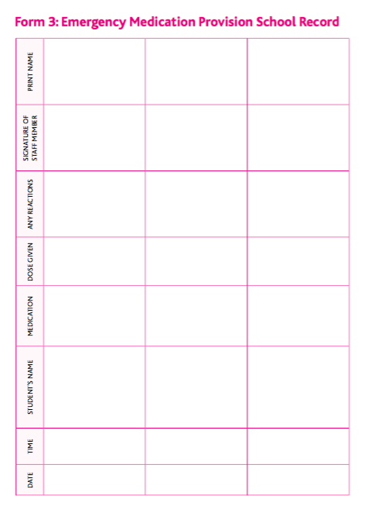

APPENDIX B: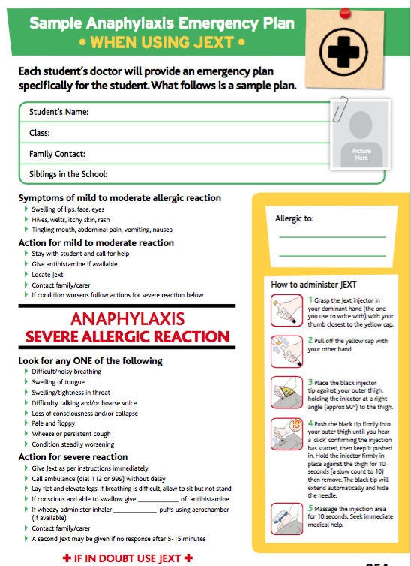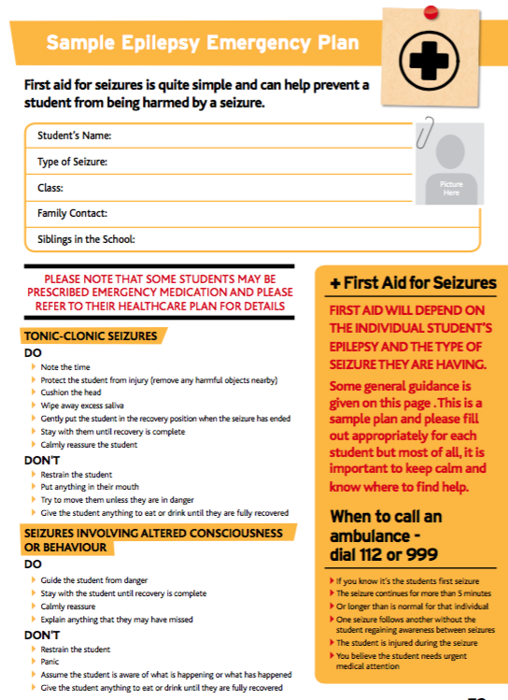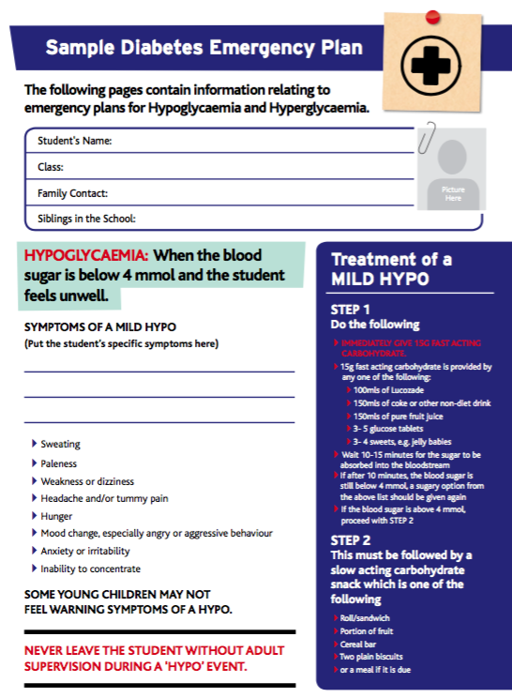 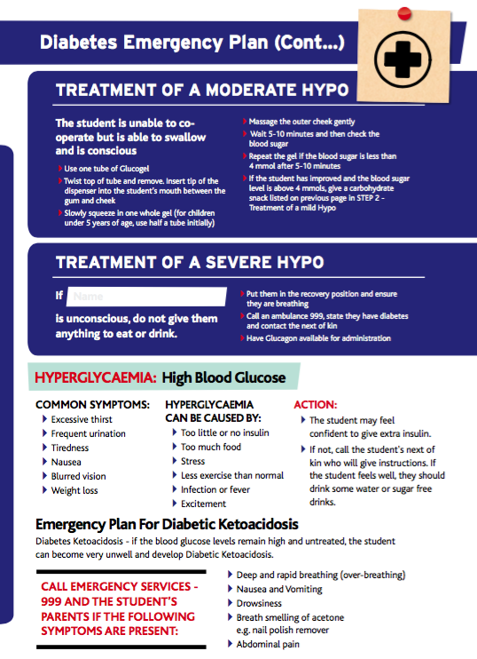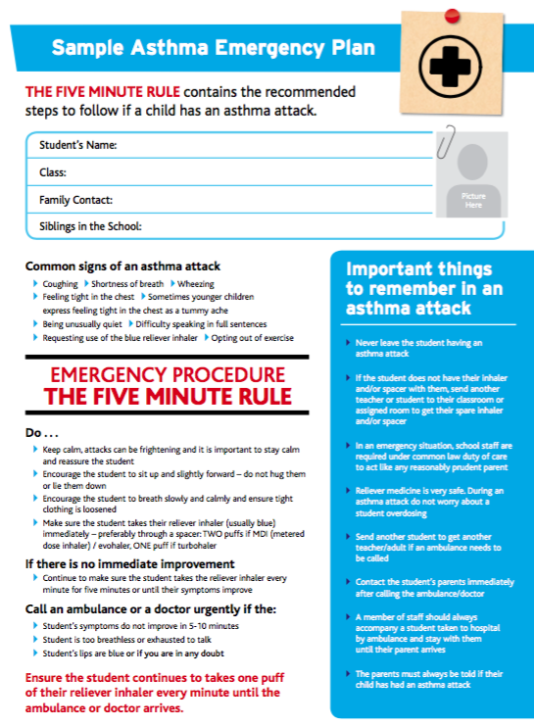

APPENDIX C:

ADMINISTRATION OF MEDICINES IN SCHOOLS INDEMNITY

THIS INDEMNITY made the ...... day of 20...... BETWEEN ....................................................................................................................

Lawful parent(s) or guardian(s ) of XXXXX, hereinafter called ‘the parents’

of the One Part AND....................................................................  
for and on behalf of the Board of Management of XXXX School, situated at XXXX in the County of XXXX (hereinafter called ‘the Board’) of the Other Part.

WHEREAS:  
1. The parents are respectively the lawful father and mother or guardians of ........................................................................., a pupil of the above school.  
2. The pupil suffers on an ongoing basis from the condition known as.................................

.................................................................................................................. 3. The pupil may, while attending the said school, require, in emergency circumstances, the administration of medication, viz.

...............................................................................................................

4. The parents have agreed that the said medication may, in emergency circumstances, be administered by the said pupil’s classroom teacher and/or such other member of staff of the said school as may be designated from time to time by the Board.

NOW IT IS HEREBY AGREED by and between the parties hereto as follows:

a) In consideration of the Board entering into the within Agreement, the parents, as the lawful father and mother respectively of the said pupil HEREBY AGREE to indemnify and keep indemnified the board, its servants and agents including without prejudice to the generality the said pupil’s class teacher and/or the Principal of the said school from and against all claims, both present and future, arising from the administration or failure to administer the said medicines.

IN WITNESS whereof the parties hereto have hereunto set their hands and affixed their seals the day and year first herein WRITTEN.

SIGNED AND SEALED by the parents in the presence of:

SIGNED AND SEALED by the said school authority in the presence of: