Temple Carrig School

Extra-Curricular Activities Policy

1. Introduction

The after school and lunchtime extra-curricular programme makes up an integral part of an Temple Carrig School education and provide all students with the opportunity to participate in a wide range of activities.

A very wide range of activities are offered, although not every activity is offered in every term and a cycle of sports and clubs is organised by the Extra-Curricular Coordinator. All students are encouraged to participate in and support such activities and events throughout their time in the School. In particular, students in First and Second Year are expected to participate in at least one (and preferably more) group-based extra-curricular activity.

2. Sports Provision

Temple Carrig School timetables sport at the following times:

- Physical Education
Physical Education is compulsory for students in First and Second Year where students have one double period of P.E. per week. Students participate in a wide range of activities covering all aspects of the syllabus. Health and fitness related theory and practical work is also incorporated into the schools’ P.E. curriculum.

In Fifth and Sixth Year the Leaving Cert Physical Education syllabus is offered as an fully timetabled examinable subject.

- Sports Science
A short course in Sports Science is offered as an optional subject for the Junior Cycle. Students who choose this subject study it for two periods a week for the full three year cycle. All students undertake a taster module in this subject.

- Games
Students in all years except Transition Year have one compulsory double period of Games per week. Students have the opportunity to participate in a range of sports including rugby, basketball, hockey, and athletics. Rugby is the major sport played by boys and Hockey for girls, although these sports are by no means compulsory and many students will opt for other activities.

In Transition Year, as well as traditional sports, students undertake a module that includes less typical sports such as rock climbing, stand-up paddle-boarding, hiking, skiing, dance, kayaking, martial arts, yoga and pilates. Transition Year students also travel to an outdoor pursuits centre for five days each year.

3. Arts Provision

A big effort is made to ensure that the Arts enjoys a very high status in the school. An active Arts Committee oversees the provision of a wide range of activities including Arts tours and trips, an annual Arts Week and an annual Arts Showcase Evening.

- Drama
Drama is offered as a Junior Cycle short course and as an integral part of the Transition Year Programme. Several performance opportunities take place every year, typically:
- Whole School Show (or multiple shows) – November
- First Year Panto – December
- Senior One Act Drama – January
- Transition Year Musical – Spring
- Senior Play – Late Spring
- Junior Play – Late Spring

- Music
The Music Department runs multiple choirs and bands and engages in performance activities throughout the year such as School Services, Musicals, inter-schools events and the Wicklow Sings concert. Students are encouraged to avail of the chance to undertake individual tuition in a range of instruments.

- Art
Students are encouraged to develop their interest beyond the classroom by participating in a range of competitions, including the Annual TCG Artist of the Year event every Spring.

- Creative Writing
Creative Writing is offered as a Junior Cycle short course. Students are also encouraged to develop their interest beyond the classroom by participating in a number of publications (such as the Fighting Words production). Student work is frequently compiled into anthologies which are published in the form of a book called Temple Carrig Tales.

4. Other Extra-Curricular Provision

There is a wide range of other after-school and lunchtime activities available to students. These include, debating, the Model United Nations (where TCG teams have enjoyed enormous success in inter-school competitions, the Student Council, Chaplaincy-run lunchtime clubs, a film club, a remote control car club and a weekly Wednesday hike.

5. Sports Facilities

Temple Carrig School has use of the following facilities:

- Indoor sports hall (markings for multiple sports)
- Astroturf Hockey Pitch
- Astroturf Ball Court
- Additional grass playing areas

Temple Carrig School also hires and makes use of:
- Local public swimming pools
- Local sports pitches
- Various sports complexes and leisure centres in Co Wicklow
- Other privately owned sports facilities, which may be hired from time to time

Given the very high participation rate in sports activities, the Board of Management is acutely conscious of the need to provide additional sports facilities on site and there have been substantial and ongoing efforts to achieve a plan to secure these in the next three years.

6. Equipment

Temple Carrig School is furnished with all the equipment necessary to teach/coach a wide range of sporting activities. No use of this equipment may take place without the permission of the teacher in charge.

All such equipment is maintained by the sports and caretaking staff. Teachers, students or caretaking staff when they are noticed, must report faults or defects. An independent audit of the school’s equipment will periodically take place.

7. Personnel

A qualified P.E. teacher conducts all Physical Education classes. When that teacher is absent, it may be necessary for a member of staff (without a formal P.E. qualification) may conduct the lesson.

Other members of staff who may not have any formal P.E. qualification may be timetabled to supervise Games lessons.

The school relies on the voluntary efforts of a number of teachers to look after these teams. The selection of students for teams is at the discretion of the teacher in charge. When making their decision, the teacher may take into account the students attitude, ability and previous discipline record.

The school also enlists the services of various outside personnel to complement the work of school staff. All such individuals will be suitably qualified and/or experienced. Examples of where this might happen are: swimming, canoeing, self-defence, dance, hockey, soccer, basketball and rugby.

When individuals not normally considered part of the school staff are asked to coach/teach a sporting activity to students of the school such individuals will be requested to:

- Furnish details of qualifications,
- Give permission to seek Garda clearance regarding previous convictions.

When outside agencies are employed to coach/teach sporting activities to students of the school such agencies will furnish the school with:

- A copy of their Safety Statement
- Confirmation of the qualifications of all instructors employed by the agency.

8. Supervision

Temple Carrig School acknowledges its duty of care for students during extra-curricular activities, and while on trips outside the school. Supervision of students in transit to and from activities, in corridors, changing rooms, PE Hall, viewing areas, pitches and courts will be in accordance with good practice and informed common sense.

The school appoints general supervisors at lunch and break times but there is no direct supervision of soccer/hockey/basketball matches/practice which students may organise in their own time. The school acknowledges the assistance given, on a voluntary basis, by staff who wish to encourage sporting activity at break, lunch and after school. The school also acknowledges the important contribution of prefects, and senior students in maintaining adequate supervision of sporting activities particularly at these times.

The supervision of dressing rooms and shower areas will respect the rights of students as far as is practicable. This will not undermine the health and safety obligations of the school nor the importance of maintaining good discipline at all times. Male supervisors will not enter female dressing rooms and female supervisors will not enter male dressing rooms except in the case of emergency.

All students are expected to behave in a responsible manner at all times, during games and while changing. Students must listen to and obey all instructions at these times.

All students must respect the property of others.

The school does not accept liability for items of clothing which are lost or damaged either during extra-curricular activities or while in the changing rooms. Changing rooms are not supervised while a match/sporting activity is in progress. Valuables should never be left in changing rooms and should ideally be left at home. Should a student have a particular item of value they may ask a teacher/supervisor to look after it. Neither the teacher/supervisor nor the school can accept liability should any such item be lost or go missing.

9. Trips away from the School

Sports trips organised by teachers of Temple Carrig School will follow normal guidelines as set down in the School Trips and Tours Policy.

All school rules and all school policies apply while on school trips.

All students selected for sports teams and who travel as part of a class group represent the school and the highest standards of behaviour and conduct are expected.

The school notes that students may miss academic classes when trips/matches are organised. In this event it is the responsibility of students to make every effort to catch up on work missed.

10. Teams visiting the School

A teacher from the visiting school should always supervise students who visit Temple Carrig School as part of a visiting team. Such students are responsible for their own belongings and Temple Carrig School takes no responsibility for valuables belonging to visiting students.

Supervisors of students visiting the school may be given a key to Temple Carrig School changing rooms.

11. Code of Practice and Ethics

Temple Carrig School is fully committed to safeguarding the well being of its students. Every individual in the school should, at all times, show respect and understanding for the rights of others, and the safety and welfare of others and conduct themselves in a way that reflects the ethos of the school and the guidelines contained in the Code of Ethics and Good Practice for Children’s Sport in Ireland.

The Following principles should apply when students participate in sport:

- Students will do suitable warm-up exercises.
- Students must be fit to participate.
- No performance enhancing drugs will be tolerated.
- The activity undertaken will be suitable for the age, ability and experience of the participants.
- The safety and well being of the students will be the prime concern of members of staff
responsible for providing sporting opportunities in the school.
- Appropriate clothing/footwear should be worn at all times. Other items such as gum
shields should be worn when requested.
- All injuries must be reported to the teacher.

12. Medical

Parents must inform the school, in writing, if there is a medical condition, which affects, in any way, the ability of a student to participate in physical activity.

While it may be deemed appropriate to administer basic First Aid, the school does not employ medically qualified personnel. Students who become ill or who sustain an injury while in school and who are unable to continue with PE, Games or an activity will be sent to the office and the parent/guardian will be contacted, if possible, to take the child home. In such cases, it will be the responsibility of the parent/guardian to ensure follow-up medical care if necessary.

In the event of an emergency or failing to make contact with a parent/guardian, the school may take the student immediately to a doctor or to a to hospital/medical centre where this is deemed necessary. In this instance, the school will endeavour to contact parents/guardians as soon as possible.

Students must report all injuries to the supervising teacher, immediately, or as soon as the student is aware that an injury has occurred.

13. Use of School Facilities

The Board of Management must approve all applications for hire of facilities of Temple Carrig School. A separate School Facilities Rental Policy applies. The Board of Management will only consider such applications if accompanied by written confirmation that insurance cover exists, and that such cover indemnifies the Board of Management and the Minister for Education.

Bodies, which hire any facility of the school, do so on the understanding that no areas of health or safety can be compromised. All students who come onto school property to attend activities organised by outside bodies must be adequately supervised at all times.

Any accidents or injury to persons employed by or under the supervision of bodies that hire the facilities of the school are the sole responsibility of the hiring body.

Approved by the Board of Management: 23rd August 2023

Appendix 1: Sports Injury Reporting Form

Student Name: ______________________________________ Year and Form: ___________________

Sport: ____________________ Event: __________________ Venue: ______________________

Date and Time: ______________________ Involvement (circle): Player/Referee/Coach/Spectator
TYPE OF ACTIVITY AT TIME OF INJURY   training   warm-up   competition   cool-down   other ________________________  REASON FOR PRESENTATION   new injury   aggravated injury   recurrent injury   illness   other ________________________  BODY PARTS INJURED  (circle and name)  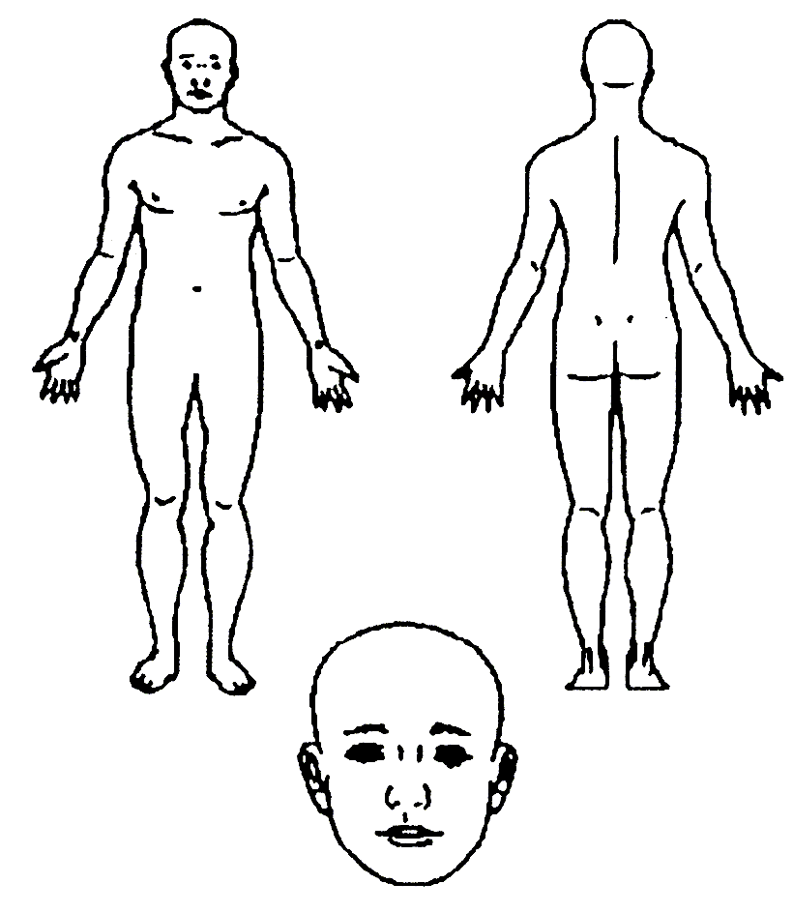  NATURE OF INJURY/ILLNESS   bruise/contusion   skin injury eg. graze, cut, blister   concussion (including suspected)   loss of consciousness   strain or sprain   dislocation (including suspected)   fracture (including suspected)   inflammation/swelling   respiratory problem   overuse injury   other ________________________ | CAUSE OF INJURY   collision with fixed object   collision with another participant   slip/trip/fall/stumble   awkward landing after jumping   struck by ball/object   struck by another player   overexertion   overuse   dehydration/temperature-related   other ________________________  Explain how the injury occurred  _____________________________  _____________________________  _____________________________  _____________________________  _____________________________  Any contributing factors?  (Eg. foul play, unsuitable footwear, faulty equipment, poor surface)  _____________________________  _____________________________  Was protective equipment worn on the injured body part?  Yes/No (circle one and add details)  ACTION TAKEN   none given/not considered necessary   removal from play   stretch/exercises   ice pack/freeze spray   dressing/bandage   immobilisation   strapping/taping   sling/splint   transport from field/court   CPR   other ________________________ | ADVICE GIVEN   safe to return to play immediately   return to play with restriction   unable to return at present   referred for further assessment before returning to activity  REFERRAL   no referral   medical practitioner   ambulance   parent to monitor   parent to bring to hospital/A&E   physiotherapist   other ________________________  PROVISIONAL SEVERITY ASSESSMENT  by the most qualified person treating the injury. Note: It is fully accepted that teachers/coaches are not medical professionals and can only do their best   minor – no measures necessary   mild (1-7 days modified activity)   moderate (8-21 days)   severe (more than 21 days)  TREATING PERSONS   teacher/coach   medical practitioner   physiotherapist   other ________________________  Post Injury Follow-up  _____________________________  _____________________________  _____________________________  Role of person reporting the injury  _____________________________  Signature of person reporting  _____________________________  DATE: ________________________

Appendix 2: Sports Injury Websites

IRFU Concussion Protocols

https://www.irishrugby.ie/playing-the-game/medical/irfu-concussion-protocols/

Graduated Return to Play System

https://d2cx26qpfwuhvu.cloudfront.net/irfu/wp-content/uploads/2019/01/30172151/GRTP-Wallet-Card-Final.pdf

IRFU Guide to Concussion

https://d2cx26qpfwuhvu.cloudfront.net/irfu/wp-content/uploads/2019/01/30172053/IRFU-Concussion-Brochure-2018.pdf

